PROPOSAL to

VICTORIA GREENWAYS ADVISORY COMMITTEE

RYAN & IVY GREENWAY

It is recommended that the Ryan & Ivy Greenway in the Oaklands area be recognised that is has the potential to be designated an “Approved Example Greenways Project” of the City of Victoria Greenways Plan.

The double wide Ryan Street west from Oaklands School has an impressive closed canopy row of large Garry Oak trees. A normal single width of road is paved and the remaining right-of-way is primarily an unmanaged, gravel parking area. Ryan Hill is a steep hill with Garry Oaks, and native plants such as camas. Some of the Garry Oaks and native plants are dying and being choking by the black berries and other weeds.

There is a safety concern for children attending Oaklands school as there is no designated pedestrian access on the north side of Ryan Street, including Ryan Hill.

Ivy Place is a short dead-end street branching off Ryan Street. Past the dead-end the right-of-way carries on, but without an actual road. People have been randomly scrambling down the rocks. Small pockets of impressive displays of trees, native plants, and rock formations are being overgrown by an unmanaged mass of weeds.

This project identifies a number of targeted, relatively small improvements in the area which could result in impressive results in a short period of time. By making these improvements an “Approved Example Greenways Project”, the Draft Greenways Plan would rightfully receive credit for helping to spawn the improvements, and therefore receive more support from individuals, groups, city council and general population of Victoria.

A well-planned pedestrian walkway would be added along the north side of Ryan street from Belmont to Cedar Hill Road, including a path up Ryan Hill. Along the walkway, the large Garry Oaks would be accommodated, as well as the needs of the churches and residents. The weeds along Ryan Hill and at the top of Ryan Street would be removed and replaced with native plants, wildflowers and trees.

The two entrances of the Ivy Place walkway could be improved. Similar greening techniques would restore the natural beauty of the special spot. A designated, rambling path would focus the human impact and improve safety. As already used informally as cross country training for Oaklands school and others, consideration would be taken into account so it could be used as a running trail as well.

Small signage could help educate visitors on the plants and, in addition, the importance of Bowker Creek and its daylighting initiatives (the area is on the watershed of the Bowker Creek).

The Garry Oak Restoration Team has identified only 6 significant Garry Oak areas in the city of Victoria. Two of those are in the Oaklands area - Oaklands School and the Cridge. There is a desire to produce a greenway corridor between them, and this project would provide an important step towards that corridor.

Ryan Street and Ryan Hill are already identified on the Greenways Map of the Draft Greenways Plan of May 8, 2003 (the Ryan & Ivy proposal is suggested to be added to Table 3).

The project follows the principles outlined in the official 1993 Oaklands Neighbourhood plan, including some specific features which are documented.

The neighbourhood is already supportive and highly educated in neighbourhood greening projects. The Holly Green Park (one block from the project) is being transformed into Garry Oak and native plant meadows. Individuals along neighbouring Asquith Street have been introducing native front gardens. Also, there is the established native garden and office of the Oaklands Greenways Project within one block of Ryan Street.

The local community is active in improving the area. For example, the Oaklands Community Centre is a progressive and vibrant community support organization. It supports local activities such as “Celebration in the Park” events. A local community initiative has been established to improve a local business corner - Haultain and Belmont. They have held a successful party for the neighbourhood. Asquith Street residents have held block parties and are building strong neighbourly ties.

With such a high level of local community involvement in various other projects in the region, it is not surprising that already individuals and groups highly supportive of this project have come forward. It is suggested that the project be championed by a local neighbourhood advisory group which would include at least one Greenways Advisory Committee member. The group would help direct the design and ensure that the concepts to truly benefit the region.

As a community effort, volunteers may be available to help in the development of the walkways. As a community developed program, the community could help in the on-going maintenance and ensure the features remain an asset to the area.

This project can be accomplished with existing municipality land and right-of-ways and would not require new land acquisition.

The project is ideal for the following reasons:
- follows very closely the principles of the Draft Greenways Plan
- Ryan Street/Hill is already designated on the Greenways Map
- restores and recovers significant Garry Oak habitat
- has strong community and neighbourhood support
- improves safety, including for the nearby school
- provides pedestrian, running, and recreation opportunities
- connections to Bowker Creek initiatives
- follows recommendations in 1993 Oaklands Neighbourhood plan
- does not required any new land acquisition
- enhances the poorly utilised existing city land
- recovers a neglected area
- strong community involvement reduces maintenance requirements

STEPS
We suggest that the Victoria Greenways Advisory Committee approve the following three steps:

- The principles outlined in this document are worth further consideration in the process of developing the Victoria Greenways Plan.

- This document accompanied by a covering letter be distributed to the neighbourhood, as a minimum delivered to all residents along the proposed route, including Oaklands School. The covering letter would invite comments and would invite residents to a meeting to formulate a Ryan & Ivy Greenways Advisory Group (which would include at least one member of the Victoria Greenways Advisory Committee).

- The Ryan & Ivy Greenways Advisory Group would meet to discuss and further develop this project. It would incorporate its comments and feedback, and then rework this document to submit back to the Victoria Greenways Advisory Committee for their review.

APPENDIX

Map layout

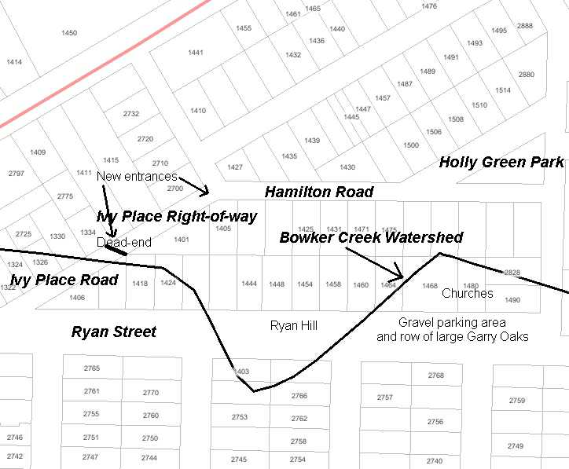

The definition of a “Approved Example Greenways Project” has been documented in a separate comment submission to the Greenways Plan.
The City of Victoria is presently drafting a Greenways Plan to establish a human-powered transportation network, restore native, aquatic and cultural habitats and to provide opportunities for recreation. The Advisory Committee has produced a draft Greenways Plan document for general circulation on May 8, 2003. Comments and feedback were due back June 16. This Council hearings and budget approvals are to follow, with the final roll out anticipated for early 2005.
Page 20 [T4.3] - “The redefinition of Ryan Street west of Belmont with an appropriate designed curb, sidewalk and landscaped boulevard”. Page 23 [P3] – “A landscaping program should be undertaken in conjunction with the proposed traffic improvements in the vicinity of Oaklands School for the Ryan Street right-of-way. The over-sized right-of-way is both untidy and unsafe in its present configuration and can be improved with limited investment. Repaving of the road is required and, at the very least, part of the right-of-way should be designated for pedestrians. Design options should be developed to review with adajacent property owners, neighbours, and staff and the Parent Consultative Committee of Oaklands School.”

